Subject: Programming with Java
ASSIGNMENT No : 8
TITLE :Write a Java program to demonstrate the use of the super keyword in inheritance.
Problem Statement
Write a Java program to demonstrate the use of the super keyword in inheritance.
Learning Objectives
To demonstrate the use of the super keyword for accessing parent class members.
Theory
The super keyword is used to refer to the immediate parent class in Java. It can invoke parent class constructors, access parent class variables, and call overridden methods. Super helps distinguish between parent and child class members with the same name. It ensures proper constructor chaining during object creation. It is an important concept in inheritance and method overriding.

Outcome
After completing this experiment, we learned how to use the super keyword in Java inheritance. We understood how super is used to call the parent class constructor, access parent class variables, and invoke parent class methods. The experiment improved our understanding of inheritance and constructor chaining in object-oriented programming.
Conclusion:
The experiment successfully demonstrated the use of the super keyword in Java. It showed how super helps access parent class members, invoke parent class constructors, and call overridden methods, ensuring proper inheritance and code reusability. The super keyword is an essential feature of Java that simplifies inheritance and improves the structure and readability of object-oriented programs.

Exercise
1.Create an Employee and Manager program where Manager accesses Employee details using super keyword.
CODE:
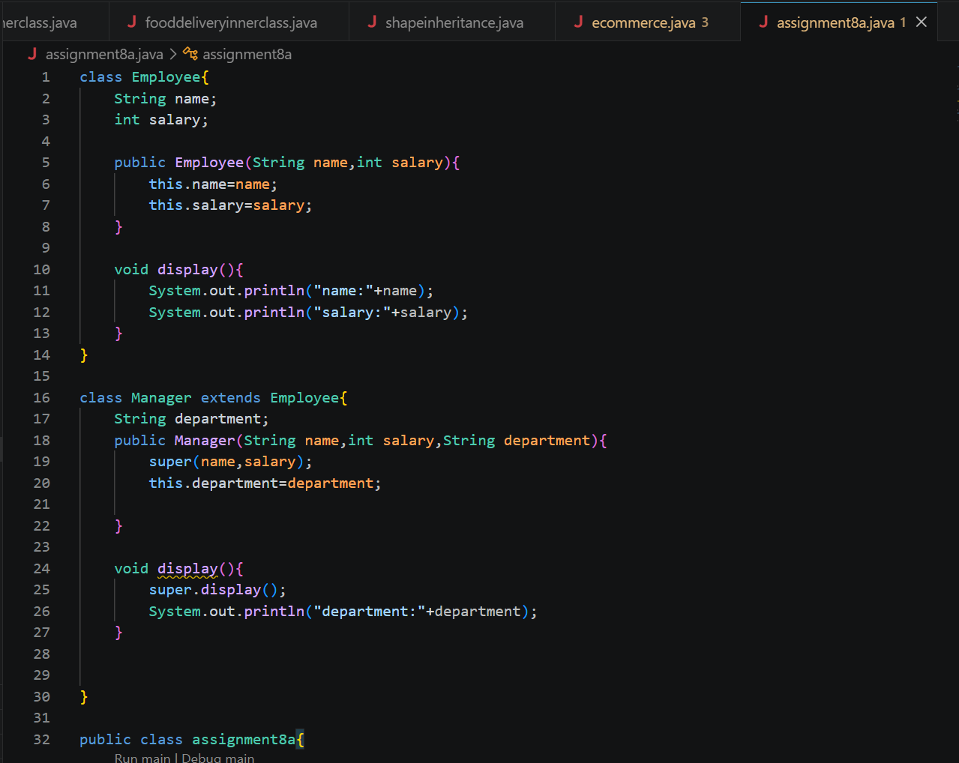


Output:
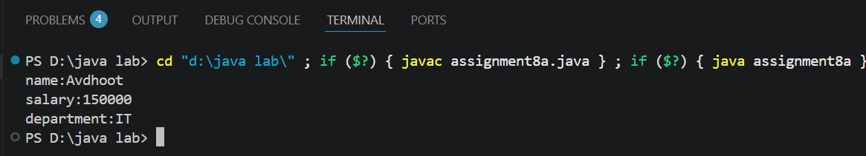

2. Develop a Vehicle Insurance System where child insurance classes access parent vehicle information using the super keyword.
CODE:
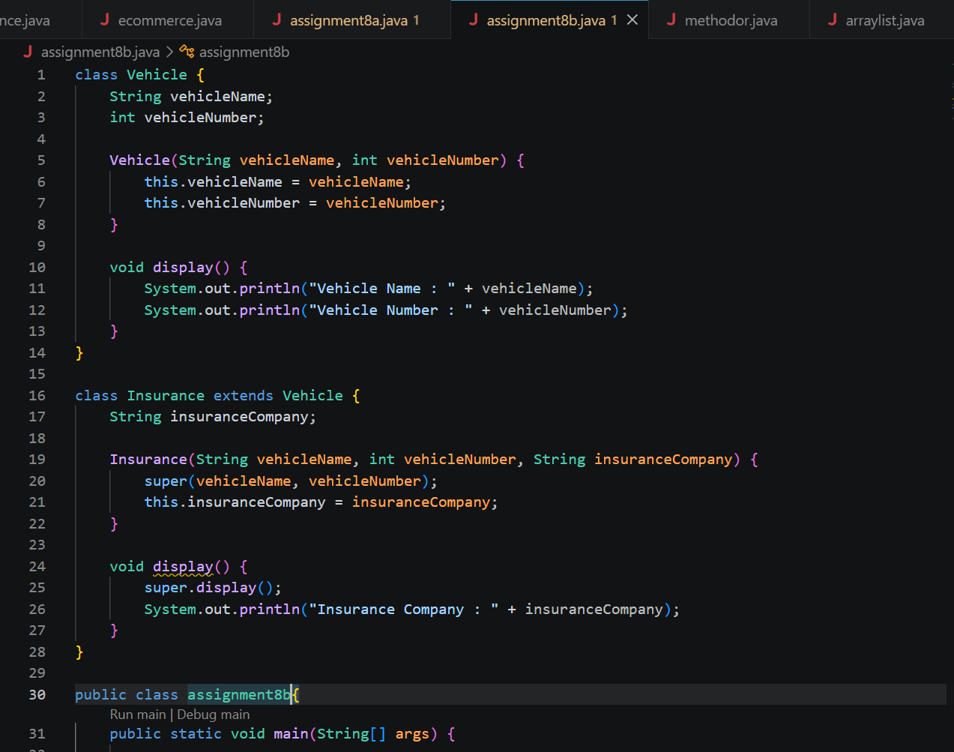


Output:
